Oral Verruciform Xanthoma - Case report and review of a clinical diagnostic enigma
Dr. Mandavi S. Waghmare^{*1}, Dr. Ronak A.Varyani², Dr. Nisha N. Bharos³, Dr. Apurva Dhabarde⁴
^{*1}Department of Oral Medicine and radiology, DY Patil University School of Dentistry, Navi Mumbai,Maharashtra,India.
²Department of Oral Medicine and radiology, DY Patil University School of Dentistry, Navi Mumbai,Maharashtra,India.
Email ID: ronakvaryani@gmail.com
³Department of Oral Medicine and radiology, DY Patil University School of Dentistry, Navi Mumbai,Maharashtra,India.
Email ID: nishabharos0805@gmail.com
⁴Department of Oral Medicine and radiology, DY Patil University School of Dentistry, Navi Mumbai,Maharashtra,India.
Email ID: apurvadhabarde24@gmail.com
*Corresponding Author:
Dr. Mandavi S. Waghmare
Email ID: mandavi.waghmare@dypatil.edu

ABSTRACT
Oral verruciform xanthoma is a rare benign lesion characterized by the presence of foamy histiocytes.This case report presents a verruciform xanthoma on the mandibular alveolar ridge in a 45-year-old male, presenting as a painless, papillomatous growth. Histopathology revealed hyperplastic epithelium with foamy histiocytes, confirmed by CD68 positivity. Surgical excision was curative, with no recurrence at 6 months. Oral Verruciform xanthoma mimics malignant or premalignant conditions, demanding histopathological confirmation. This case highlights the importance of multimodal diagnosis along with a review of all reported cases in the last decade.
Keywords: Hyperplasia, CD68, foam cells, histiocytes, IHC, papillary growth.
How to Cite: Dr. Mandavi S. Waghmare, Dr. Ronak A.Varyani, Dr. Nisha N. Bharos, Dr. Apurva Dhabarde, (2025) Oral Verruciform Xanthoma - Case report and review of a clinical diagnostic enigma, Journal of Carcinogenesis, Vol.24, No.7s, 1-5

- INTRODUCTION
Oral Verruciform Xanthoma (OVX) is an uncommon benign lesion often closely mimicking other verrucous and papillary lesions in oral cavity. It typically presents as a solitary,sessile or pedunculated lesion with a slow-growing nature, well demarcated and might be painless with a verrucous or papillomatous surface, most frequently affecting the oral mucosa. ^{[1,2]} The buccal mucosa, hard palate, and lips are the most common intraoral sites, though cases have also been reported in extraoral locations such as the genitalia and skin. There is a slight male predilection noted along with prevalence mostly in fifth to seventh decade of life. ^{[2,3,4]}
Histologically, OVX is characterized by parakeratosis, epithelial hyperplasia, and the presence of lipid-laden foam cells also called as xanthoma cells within the connective tissue papillae. ^{[3]} This report presents a case of OVX involving the left mandibular alveolar ridge and sheds light on emphasis of its diagnostic importance.
- Case report
Clinical findings:
A 45 year old male patient reported to the department of oral medicine and radiology with a 6 month history of a painless, exophytic growth on the left mandibular alveolar ridge in 36,37 region. The patient had a history of tobacco chewing for nine years, however he had quit the habit since two years. The patient had no significant medical,sexual or trauma related history to the affected site. Intraoral examination of the patient revealed a solitary, sessile, well circumscribed, grayish white papillomatous lesion measuring about 1 x 0.5 cm. Distal end of the lesion was raised, granular and pebbly while the anterior aspect of lesion was more flattened and smooth. The lesion was asymptomatic and had a firm consistency. There was no associated bleeding, ulceration, or regional lymphadenopathy.

Diagnostic assessment:
Based on the clinical presentation as shown in [Figure 1], a diagnosis of oral papilloma was made. Alongside, a differential diagnosis of verrucous leukoplakia and verruca vulgaris was considered.
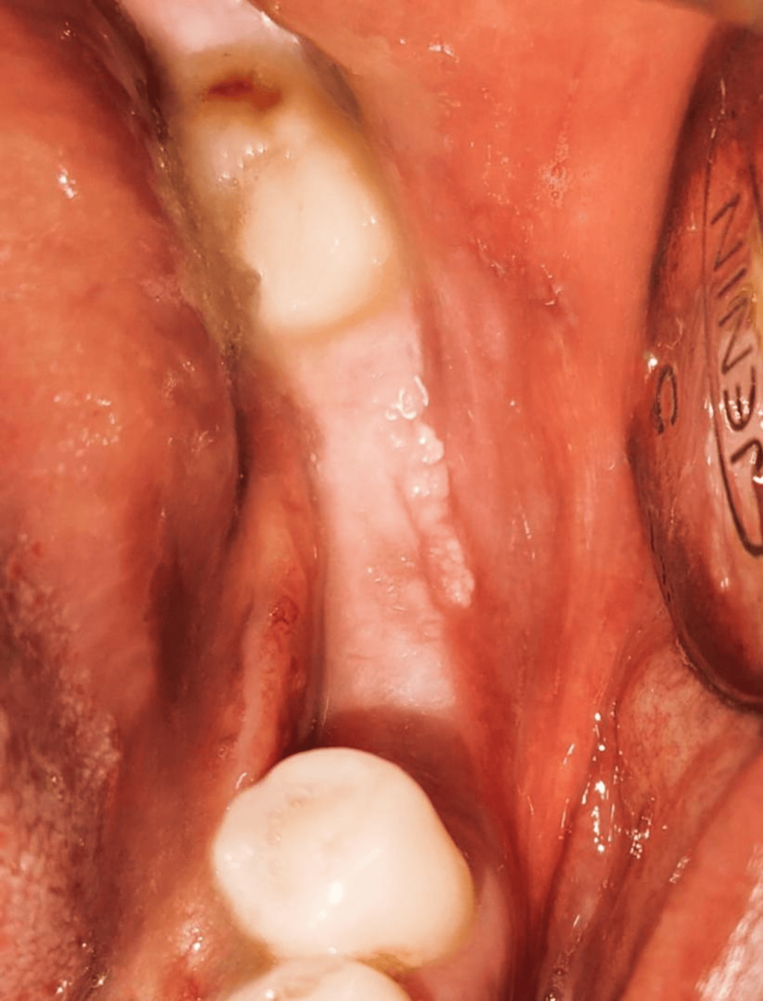
Figure 1: Clinical appearance of the lesion in alveolar mucosa of 36,37 region at initial visit.

Surgical intervention:
After clinical inspection of the lesion, an excisional biopsy was carried out for confirmatory diagnosis. Histopathology of the lesion with Hematoxylin and Eosin (H&E) stain showed hyperplastic epithelium with uniformly elongated rete ridges, acanthosis along with few areas of parakeratin plugging. Additionally,foamy histiocytes or foam cells were also noted in the connective tissue papilla with underlying fibrocellular connective tissue stroma. Based on these findings a diagnosis of oral verruciform xanthoma was given. Immunohistochemistry (IHC) with anti-CD68 marker revealed positive expression in relation to foam cells or foamy histiocytes. [Figure 2]
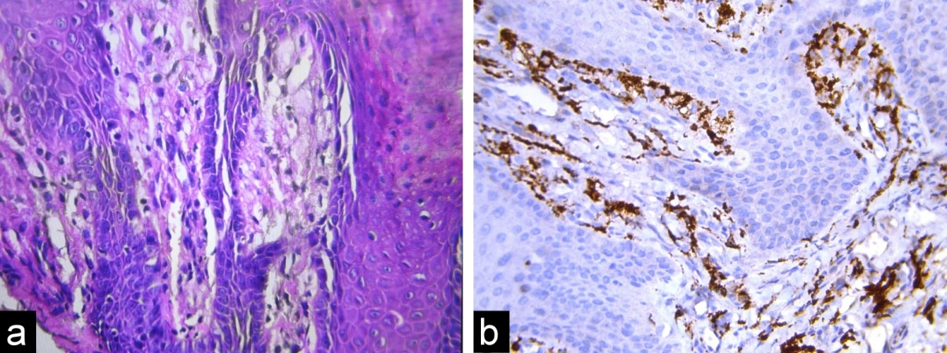
Figure 2: (a) Photomicrograph of OVX (H&E at 40x) showing foam cells in connective tissue papillae. (b) Photomicrograph of OVX after IHC (40x) showing CD68+++ form cells.

Follow up and outcome:
The patient was followed up and no recurrence has been noted for the past 6 months.
- Discussion
Oral verruciform xanthoma (OVX) is an uncommon benign lesion characterized by accumulation of lipid laden foam cells in the connective tissue papillae. Since its first elucidation by Shafer in 1971, our understanding of lesions of OVX has grown, but several aspects of its etiopathogenesis remain controversial, however Ox-LDL (oxidation of lipids) and monocytic-macropahgic lipid engulfment hypotheses are most widely accepted theories. Its estimated prevalence ranges from 0.025% to 0.05% among oral lesions, highlighting its rarity. ^{[5,6,7]}
While the lesions are more prevalent in the fifth to seventh decade, a recent review reported OVX within a wide age range of 14 to 84 years. Average lesion size ranges between 0.1cm to 2.5 cms with a slight male predilection,with a male-to-female ratio of 3:1. The lesions are usually asymptomatic.
OVX typically occurs independently, but few cases have been reported in association with OPMDs (oral premalignant disorders), GVHD (Graft versus host disease), DLE (Discoid Lupus Erythmatosus), OSCC (oral squamous cell carcinoma), amyloidosis, pemphigus vulgaris, neurofibromatosis, osteoma, and warty dyskeratoma. ^{[7,8].} A review of all reported cases in the last decade is listed in [Table 1]

Table 1: Review of all reported cases of OVX over the last decade
Author | Year | No of cases | Age | Location | Size | IHC Findings
Garcia AS et al. [10] | 2016 | 1 | 43/M | Hard palate | 0.5 cm | CD68+ foam cells, Ki-67 negative
Pereira T et al. [11] | 2016 | 1 | 59/M | Lower lip | 0.5×1 cm | CD68+ xanthoma cells
Hiraishi Y et al. [12] | 2016 | 1 | 65/F | Left lateral part of tongue | 1.5×1 | CD68+ foam cells
Kimura M et al. [13] | 2016 | 1 | 64/M | Lower gingiva. | 0.7×0.7cm | CD68+ foam cells
Cebeci F et al. [14] | 2017 | 1 | 61/M | Lower Lip | 0.5x0.7cm | CD68++ form cells
Theofilou VI et al. [15] | 2018 | 1 | 56/F | Left lateral border of tongue | 1.0×0.5×0.3cm | CD68+ foam cells
Gannepalli et al. [16] | 2019 | 1 | 52/M | Attached gingiva | 0.8×2cm | CD68+++ foam cells
Medeiros CKS et al. [17] | 2022 | 1 | 74/F | Buccal mucosa | 1.8cm | CD68+ xanthoma cells
Preto KA et al. [18] | 2024 | 2 | 30/M | Floor of mouth | 1 cm | CD163+, CD68+, S-100-
Chatterjee A et al [19] | 2024 | 1 | 20/M | Lower Lip | 1.5x 1 cm | CD68++, S100-
Tamgadge S et al [20] | 2024 | 1 | 36/M | Lower labial mucosa | 1.5x 1.5 cm | CD68++
Choudhari S et al. [1] | 2025 | 1 | 58/M | Left buccal mucosa | 2x3cm | CD68+  foamy cells
Despite its distinct histopathologic features, OVX presents a diagnostic challenge due to its clinical resemblance with other verruco-papillary lesions of the oral cavity. These include oral squamous papilloma (a whitish, pedunculated papillary lesion caused by HPV 6 and 11), verruca vulgaris (a well-demarcated, firm papillary lesion associated with HPV 2 and 4), condyloma acuminatum (a soft, pink, cauliflower-like lesion with a broad base), verrucous hyperplasia (a white, plaque-like or exophytic lesion lacking OVX’s characteristic yellowish hue), and focal epithelial hyperplasia or Heck’s disease (multiple soft, flat-topped papules caused by HPV 13 or 32). Among malignant entities, verrucous carcinoma, which is locally aggressive unlike OVX, while squamous cell carcinoma may exhibit a verrucoid morphology with frequent lymph node involvement, distinguishing it from OVX. However, We can only differentiate these lesions from OVX clinically upto a limited extent. ^{[1,9]}
Treatment for OVX is complete surgical excision, which is usually entirely sufficient. Recurrences are extremely rare however nine cases have been documented in literature so far.^{[1]} Nevertheless, removal of the causative factor might reduce the incidence of recurrence.
- Conclusion
OVX is a rare, benign lesion often mimicking malignant or premalignant conditions, entailing histopathological confirmation. Surgical excision is the definitive treatment, with minimal recurrence risk. This case highlights the importance of a multimodal diagnosis and ensure appropriate management.

REFERENCES
- Choudhari SS, Patankar SR, Mhatre VS, Gupta A: Verruciform xanthoma: A case report and a review of recurrent cases. J Oral Maxillofac Pathol. 2025, 29:152-7. 10.4103/jomp.jomp_125_23
- Philipsen HP, Reichart PA, Takata T, Ogawa I: Verruciform xanthoma—biological profile of 282 oral lesions based on a literature survey with nine new cases from Japan. Oral Oncol. 2003, 39:325-36. 10.1016/S1368-8375(02)00075-8
- Neville BW, Weathers DR: Verruciform xanthoma. Oral Surg Oral Med Oral Pathol. 1980, 49:429-34. 10.1016/0030-4220(80)90013-1
- Blankenship DW, Zech L, Mirzabeigi M, Venna S: Verruciform xanthoma of the upper-extremity in the absence of chronic skin disease or syndrome: a case report and review of the literature. J Cutan Pathol. 2013, 40:745-52. 10.1111/cup.12157
- Shafer WG: Verruciform xanthoma. Oral Surg Oral Med Oral Pathol. 1971, 31:784-9. 10.1016/0030-4220(71)90412-1
- Lalawat S, Tomar N, Chaudhary A, Reddy V: Oral verruciform xanthoma: The great imitator. J Indian Acad Oral Med Radiol. 2020, 32:196-8. 10.4103/jiaomr.jiaomr_34_20
- Hegde U, Doddawad VG, Sreeshyla HS, Patil R: Verruciform xanthoma: A view on the concepts of its etiopathogenesis. J Oral Maxillofac Pathol. 2013, 17:392-6. 10.4103/0973-029X.125205
- Bar O, Elad S, Avni B, et al.: Oral verruciform xanthoma in chronic graft-versus-host disease patients. Support Care Cancer. 2021, 29:79-84. 10.1007/s00520-020-05681-w
- Dorankula SP, Ramani P, Premkumar P, Anuja K, Sherlyn HJ: Verruciform xanthoma of the oral cavity—A case report. J Clin Diagn Res. 2013, 7:1799-801. 10.7860/JCDR/2013/6221.3323
- Garcia AS, Pagin O, da Silva Santos PS, Oliveira DT: Verruciform xanthoma in the hard palate: a case report and literature review. J Korean Assoc Oral Maxillofac Surg. 2016, 42:383-7. 10.5125/jkaoms.2016.42.6.383
- Pereira T, Shetty S, Dodal S, Tamgadge A: Verruciform xanthoma of the lip: A rarity. Indian Dermatol Online J. 2016, 7:180-2. 10.4103/2229-5178.182356
- Hiraishi Y, Tojyo I, Kiga N, Tanimoto K, Fujita S: A Case of Verruciform Xanthoma Arising in the Tongue. J Clin Diagn Res. 2016, 10:07-08. 10.7860/JCDR/2016/22157.8965
- Kimura M, Ohto H, Shibata A, Enomoto A, Umemura M: Clinicopathological and Immunohistochemical Characteristics of Verruciform Xanthoma of the Lower Gingiva: A Case Report. J Clin Diagn Res. 2016, 10:05-06. 10.7860/JCDR/2016/15446.7950
- Cebeci F, Verim A, Somay A, et al.: Verruciform xanthoma of a lower lip lesion: a new case and review of the literature. Case Rep Dermatol. 2017, 9:130-5. 10.1159/000477961
- Theofilou VI, Sklavounou A, Argyris PP, Chrysomali E: Oral Verruciform Xanthoma within Lichen Planus: A Case Report and Literature Review. Case Rep Dent. 2018:1615086. 10.1155/2018/1615086
- Gannepalli A, Appala A, Reddy L, Babu DBG: Insight into verruciform xanthoma with oral submucous fibrosis: Case report and review of literature. J Oral Maxillofac Pathol. 2019, 23:43-8. 10.4103/jomfp.JOMFP_210_18
- Medeiros CKS, de França GM, da Silva WR, Felipe J, Galvão HC, de Oliveira PT: Verruciform xanthoma associated with lichen planus. Autops Case Rep. 2022, 12:2021360. 10.4322/acr.2021.360
- Preto KA, Lopes-Santos G, Zanda MJ, Oliveira DT: Oral verruciform xanthomas mimicking potentially malignant disorders. J Clin Exp Dent. 2024, 16:539-42. 10.4317/jced.61411
- Chatterjee A, Purkait SK, Banerjee I, Banerjee A, Ramalingam K: Oral Verruciform Xanthoma of the Lower Lip: A Rare Entity. Cureus. 2024, 16:73352. 10.7759/cureus.73352
- Tamgadge S, Pereira T, Vaidya A, Punjabi V: Oral verruciform xanthoma (OVX) of lower labial mucosa, presenting as a plaque in tobacco users: an unusual case report with literature review. Ecancermedicalscience. 2024, 18:1796. 10.3332/ecancer.2024.1796

